Launched an EC2 instance and installed a web server nginx. Then, created an EBS volume of 5 GB, attached it to an EC2 machine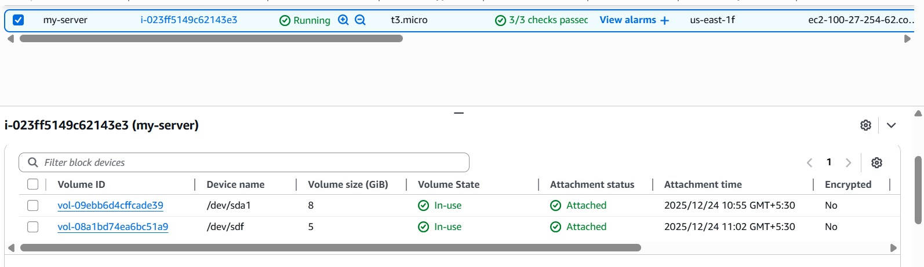
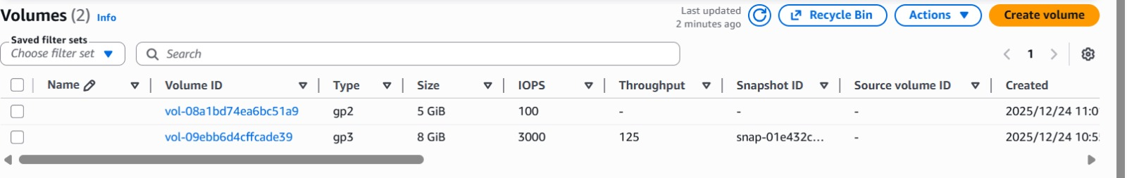

Now took a snapshot of ebs
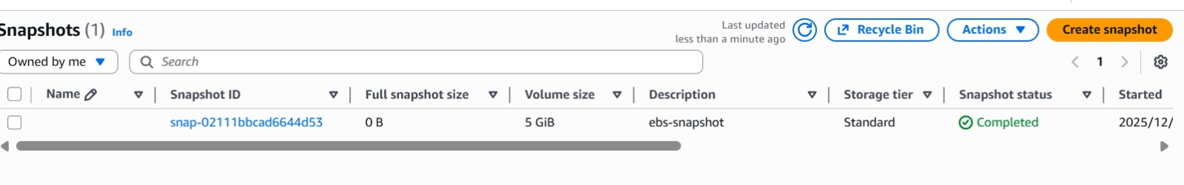

From snapshot created a volume
